# In the name of God Convex optimization CHW3 report

Mahyar Ghazanfari 98102057



# Q1. Optimal evacuation:

The optimization problem is:

𝑇

𝑇−1

𝑚𝑖𝑛𝑖𝑚𝑖𝑧𝑒 ∑(𝑟𝑇𝑞𝑡 + 𝑠𝑇𝑞2) + ∑(𝑟̃𝑇|𝑓𝑡| + 𝑠̃𝑇𝑓2)

𝑡

𝑡

𝑡=1 𝑡=1

𝑠𝑢𝑏𝑗𝑒𝑐𝑡 𝑡𝑜 𝑞𝑡+1 = 𝐴𝑓𝑡 + 𝑞𝑡, 𝑡 = 1,2, . . 𝑇 − 1

0 ≤ 𝑞𝑡 ≤ 𝑄, 𝑡 = 2, … , 𝑇

|𝑓𝑡| ≤ 𝐹,

𝑡 = 1,2, … . 𝑇 − 1

With variables 𝑞2, … , 𝑞𝑡 and𝑓1, … , 𝑓𝑡−1. The problem is solved and optimal evacuation is obtained as 17. You can run the code and verify this answer.

# Q2. Optimal circuit design:

The equivalent optimization problem that can be solved is as below:

𝑓𝑖𝑛𝑑

θ

𝑘

𝑠𝑢𝑏𝑗𝑒𝑐𝑡 𝑡𝑜 ∑

θ𝑗 log 𝑃(𝑗) ≤ log 𝑃𝑠𝑝𝑒𝑐

𝑗=1

𝑘

∑

θ𝑗 log 𝐷(𝑗) ≤ log 𝑃𝑠𝑝𝑒𝑐

𝑗=1

𝑘

∑

θ𝑗 log 𝐴(𝑗) ≤ log 𝑃𝑠𝑝𝑒𝑐

𝑗=1

1𝑇θ = 1, θ ≥ 0

In fact we found a blend that meets the specifications by solving the LP feasibility problem. Θ Is the blending parameter.

If the LP above is feasible, then the blend obtained from the feasible Θ must satisfy the design specifications. We can make this statement without knowing the specific posynomial expressions for P, D and A which are designing criteria. It is indeed nothing more than Jensen’s inequality.

On the contrary, if the LP above is infeasible, then we cannot say anything. The design specifications could be infeasible, or feasible; we don’t know.

# Q3. Filling covariance matrix:

Part a: Let’s take 𝑆 = 𝑇 = [1 1 . Then we will have:

# ] 1

1

|  |  |  |  |
| --- | --- | --- | --- |
| 1 | 1 | 0 |  |
| = [1 | 1 | 1] | → det(𝐶𝑠𝑖𝑚) = −1 |
| 0 | 1 | 1 |  |

𝐶𝑠𝑖𝑚

Since 𝐶𝑠𝑖𝑚 is not positive definite (PSD), it cannot be a covariance matrix.

Part b: 𝐶𝑠𝑖𝑚 would be the answer of the problem, if it is PSD, because:

||𝐶 − 𝐶

||2 = ||𝐶

− 𝑆

2

|| + 2||𝐶

− 𝑆

2

|| + ||𝐶

||2 + || |𝐶

− 𝑠22 + 𝑇22| ||2

𝑠𝑖𝑚 𝐹

11 11 𝐹

12 12 𝐹

13 𝐹

22 2 𝐹

+ 2||𝐶23 − 𝑇23||2 + ||𝐶33 − 𝑇33||2

→ 𝐶 = 𝑆 , 𝐶

𝐹

= 𝑆 , 𝐶 = 0, 𝐶

𝐹

= 𝑆22 + 𝑇22 , 𝐶

= 𝑇 , 𝐶 = 𝑇

11 11 12

12 13 22

2 23

23 33 33

# Q4. Control using different objective functions:

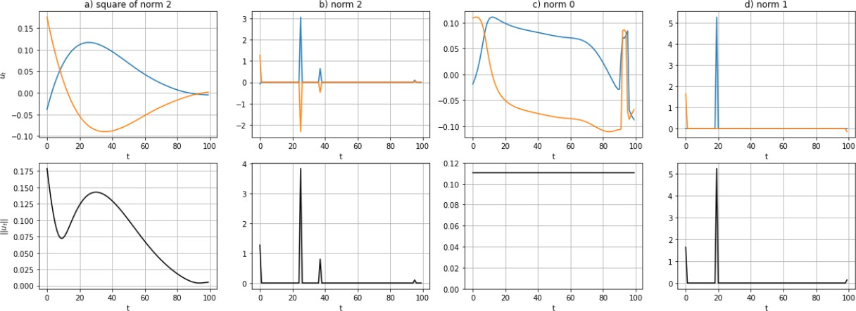

Look at the results obtained from code. From left to right we discuss about control inputs:

1: The control inputs are small; but not sparse. This is what we expect with the least squares.

2: The control input is sparse; and when control is nonzero, both components are nonzero.

3: The second norm of the control input is constant over time, the direction of the control input changes over time however.

4: The control input is sparse; the different components are nonzero in different times.

# Q5. Portfolio optimization:

The mean worst case risk portfolio problem could be reformulated as:

𝑚𝑖𝑛𝑖𝑚𝑧𝑖𝑒 − 𝜇𝑇𝑤 + 𝛾𝑡

𝑠𝑢𝑏𝑗𝑒𝑐𝑡 𝑡𝑜 𝑤𝑇∑(𝑘)𝑤 ≤ 𝑡, 𝑘 = 1, … , 𝑀 1𝑇𝑤 = 1

With variables 𝑤 ∈ 𝑅𝑛 and 𝑡 ∈ 𝑅. Let 𝜆𝑘 be a dual variable for the kth inequality constraint, and 𝑣 be a dual variable for the equality constraint. The KKT conditions are then:

−𝜇 + 𝑣1 + ∑ 2𝜆𝑘∑(𝑘)𝑤 = 0

𝑘

𝛾 − ∑ 𝜆𝑘 = 0

𝑘

1𝑇𝑤 = 1

𝑤𝑇∑(𝑘)𝑤 ≤ 𝑡

𝜆𝑘(𝑤𝑇∑(𝑘)𝑤 − 𝑡) = 0, 𝑘 = 1,2, … 𝑀

𝛾 ≥ 0

In a similar way, the KKT conditions for the problem:

𝑀

𝑚𝑎𝑥𝑖𝑚𝑖𝑧𝑒 𝜇𝑇𝑤 − ∑ 𝛾𝑘𝑤𝑇∑(𝑘)𝑤

𝑘=1

𝑠𝑢𝑏𝑗𝑒𝑐𝑡 𝑡𝑜 1𝑇𝑤 = 1

Are

−𝜇 + α1 + ∑𝑘 2𝜆𝑘∑(𝑘)𝑤 = 0

1𝑇𝑤 = 1

Where 𝛼 is a dual variable for the equality constraint. Now using python, we solve the optimization problem and get the results as follows:

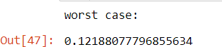

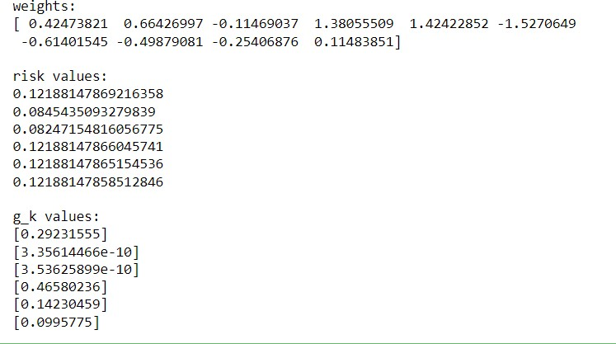

The python code is provided in the zip file.